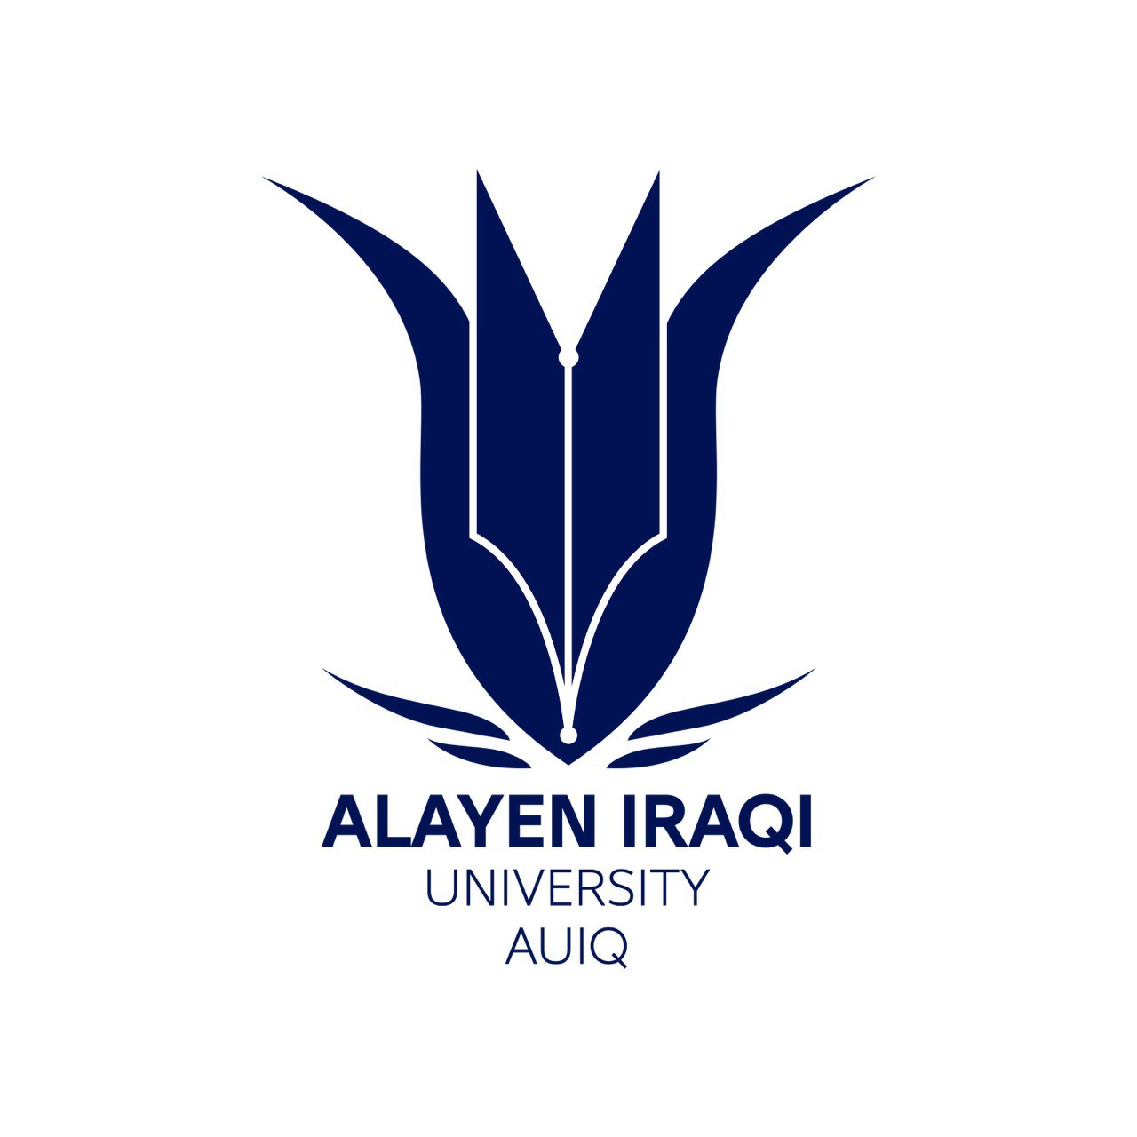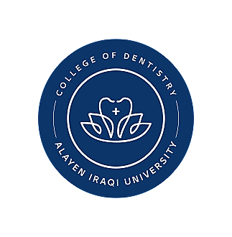
CV
Name: mohammed gyad hares
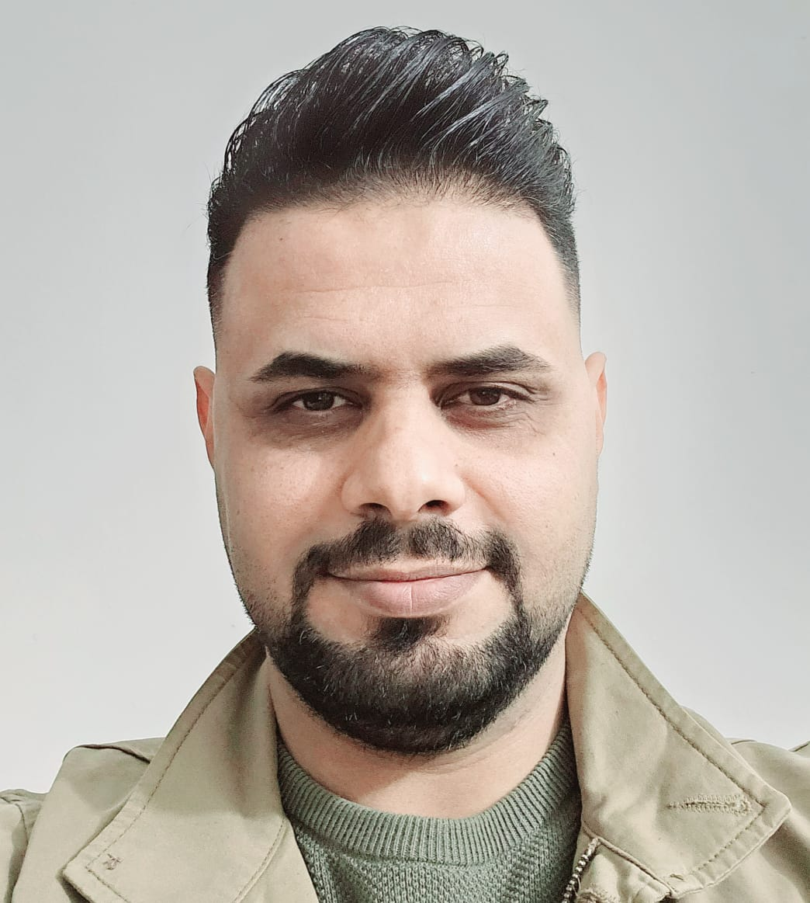Photo
Date of birth: 22 .6.1984
Religion: Muslim
Marital Status Married: Married
No. of Children: 2
Position: rapporteur of department
Specialization: conservative and esthetic dentistry
Scientific degree: Assistant of lecture
Work Address: Al Ain University - Nasriyeh
Work Phone: 078o64oo212
Mobile/ 07811515958
Personal Email: Drmohnnn@gmail.com
university Email:
First, Scientific Certification:
Degree Science | University | College | Date
B.Sc. | University of Baghdad | Faculty of Dentistry | 2007_2008
M.Sc. | University of Baghdad | Dentistry | 2013
Ph.D.

Second, Career:
No. | Career | Workplace | From-To
 | Dentist | Private clinic | 2010-2023

Third, University Teaching:
No. | University | The Institute/College | From-To
 | Al Ain  University | Faculty of Dentistry | 2018-present

Fourth, Courses Which You Teach:
No. | Department | Subject | Year
 | Conservative dentistry | Endodontic,  Operative,  Crown and bridge | 2016-present

Fifth, Thesis which was supervised by:
No. | Thesis Title | Department | Year

Sixth, Conferences which you participated:
No | Conferences Title | Year | Place | Type of Participation

Seventh, Scientific Activities:
Within The College | Outside the college

Eighth, Research Projects in The field of Specializations to The Environment and Society or The Development of Education:
No. | Research Title | Place of Publication | Year

Ninth, Membership
*
*
Tenth, Awards and Certificates of Appreciation:
No. | Name of Awards and Certificates | Donor | Year

Eleventh, Scientific literature

No. | Scientific literature title | Year of the publication

Twelfth, Languages:
- Arabic
• English

